Disco Infernal
Tight version: One night. One club. Ghosts possess dancers. You dodge, save the DJ, find MJ's suit and moonwalk before midnight. 6-ish rooms. Survive.

Proposal
I was thinking of something in the style of the 1984 Ghostbusters game (https://www.c64-wiki.com/wiki/Ghostbusters), or Ghosts 'n' Goblins (https://en.wikipedia.org/wiki/Ghosts_'n_Goblins_(video_game)), or Hugo's House of Horrors (https://en.wikipedia.org/wiki/Hugo's_House_of_Horrors). Horror themed but not strictly horror.

My idea is a bit of a pastiche. In the 1970's — a group of mad and evil cultists made contact with an entity from the the wicked world of the Disco Infernal. They built a nightclub on the site of their ritual. The nightclub was complete and the hour of the great conjunction was near. Club-goers came and started dancing, and as they were dancing — they were taken over by spirit of disco. Had the night completed as planned — all the club goers would have been possessed and they would have gone out into the night as Disco Demons, and conquered the world. The Disco Infernal would reign supreme. They were only stopped by the timely arrival of Michael Jackson. The club has lain derelict since then.

Jump to the present — the player has inherited the club from a crazy old uncle he didn't know he had. The will stipulates he can keep the club but only if he opens it and runs by a specific date — "tonight". It's another Great Conjunction. He opens the club and is running things. As customers arrive and start to dance — ghostly disco dancers begin to appear. They start possessing the club-goers. The player has to avoid possession, keep the ghosts from possessing the DJ, and solve the mystery and save the world. Or the Disco Infernal will conquer all.

Alternative Saviour or minor optional Easter Egg: The janitor is actually Elvis. He faked his death so he could come here and guard the portal. He was here back in the 70’s, and he never left. He even sleeps here. One problem — he’s forgotten everything. And his hips are killing him.

Specs
Graphics: In the early 1980s – video graphics were CGA and EGA (320 x 200) with 640 colours. In 1987, a new standard was released — VGA. This was 640 x 480 with 256 colours. With 32x32 pixel sprites and a 320 x 240 viewport — our game is slap-bang in this era.
https://itch.io/jam/dos-vgaadlib-jam-2026-take-2
https://www.youtube.com/watch?v=cQD9EYX3bfY
https://itch.io/jam/cga-jam-2024
https://itch.io/jam/cga-jam

Sound: In 1987, Adlib released a new sound card powered by the Yamaha YM3812 (OPL2) chip. This introduced multi-channel frequency modulation (FM) to the games industry. Sound cards ran ahead of graphics cards in sophistication.
https://www.youtube.com/watch?v=QloftqK2o-I
https://www.google.com/search?client=firefox-b-d&q=AdLib+OPL2+(YM3812).+1987.+FM+synthesis.+The+sound+of+DOS+disco.#fpstate=ive&vld=cid:d4e27343,vid:ViBIGeVGgkM,st:0

Time: As this is a 1-week game jam, I propose a 15 minute game. The club opens at 8pm. The climax happens at 12am. The world runs at 16x speed. 1 game minute every 3.75 seconds.

Layout: The club contains the following areas — the main floor which has a bar with some barstools, tables and chairs. The dance floor which has a DJ booth and an old dusty disco ball. Doors to the Ladies and Gents toilets are on the back wall — we don’t need to animate those areas. A third door in the middle — next to the DJ booth — opens onto the stairwell.
Upstairs — the Office is to the right, and the owners flat is to the left.
Downstairs — the basement is divided into a boiler room to the right, and the cellar to the left.
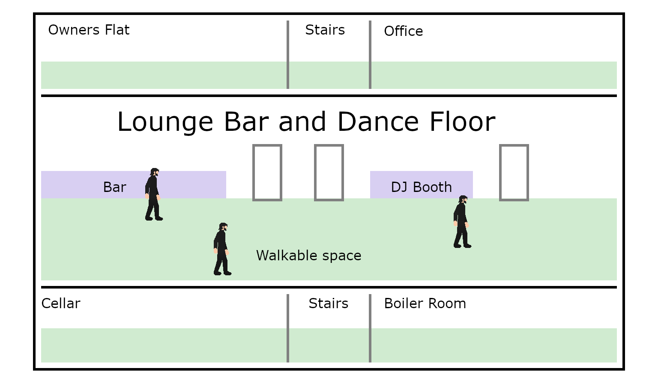

Characters

The Player
- Inherited the club from a crazy old uncle he didn’t know he had.
- The will states the club has to be open on a specific date: October 6 2026.
- Has sunk his life-savings into the club — All £9.99.
- Can see ghosts — the club goers don’t seem worried. Maybe they can’t see them.
- Has a resistance meter vs possession. Drained by ghosts or Mr Boogie-Woogie. Ticks up when resting. Replenished from bar or drinks cabinet in the office.

Mr Boogie-Woogie
- Is the BBEG
- Lurks in the basement
- Drained by acting. Rest to recharge.
- Brings boxes of disco records from the basement up to the DJ
- More powerful and active as it gets near midnight
- More active and powerful when the DJ is playing Disco
- More active when there are more ghosts and more possessed dancers

The DJ
- Stands in the DJ booth.
- Plays whatever record he is brought
- Comments on the crowd and the vibe

Raul — the barman
- His Dad used to work here back in the day. Told him tales about this place.
- Serves drinks.
- Gives info.

Vince Everett — the janitor
- Lurks in the boiler room
- Has a mop and bucket
- Looks like Elvis. Might even be Elvis
- Has been here “forever”
- Gives info
- Can make Holy Water

Customers / Dancers
- Move between the dance floor, bar, and rest rooms
- Dance
- Buy and consume drinks
- Block movement
- Can be possessed by ghosts --> becomes possessed dancer
- Can be cured with Holy Water when rock is playing

Ghosts
- Appear when Disco is playing
- Fade when Disco stops (on a timer)
- Haunt dance floor and disco ball
- Can Possess dancers when Disco is playing
- Banished by Holy Water when Rock is playing

Possessed Dancers
- Dance
- Block movement
- Demand Disco when Disco is not playing
- Can be cured with holy water when Rock is playing

Items
- Holy water
- Drinks
- Boxes of records
- Holy Water
- A clock – advances 1 min every 3.75 seconds — from 8pm to 12am (midnight)

